Progression Towards a Written Method for Division

In developing a written method for division, it is important that children understand the concept of division, in that it is:
- repeated subtraction
- sharing into equal amounts

They also need to understand and work with certain principles, i.e. that it is:
- the inverse of multiplication
- not commutative i.e. 15 ÷3 is not the same as 3 ÷ 15
- not associative i.e. 30 ÷ (5 ÷ 2) is not the same as (30 ÷ 5) ÷ 2

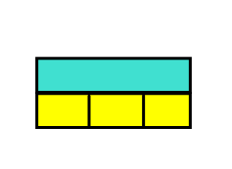
All year groups will use The Singapore Bar Method as a means of visualising and understanding division problems.

12 divided by 3 = 4

yr
Early Learning Goal:
Children solve problems, including halving and sharing.

Children are encouraged to develop a mental picture of the number system in their heads to use for calculation. They should experience practical calculation opportunities using a wide variety of equipment, including small world play, role play, counters, cubes etc.

Children will use Numicon shapes to have a firm visual image and practical aspect to division. They will see how many 2 shapes/ pegs I can fit inside the 10 shape.

Children may also investigate sharing items or putting items into groups using items such as egg boxes, ice cube trays and baking tins which are arrays.
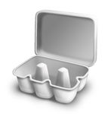
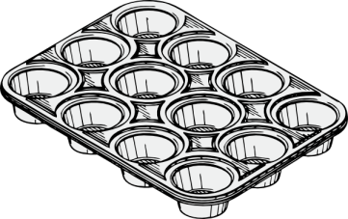

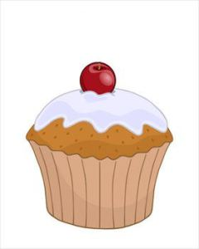
E.g. 6 cakes are shared equally between 2 people. How many cakes does each person get?

1 2

They may develop ways of recording calculations using pictures, etc.
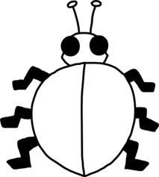
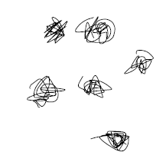
A child’s jotting showing halving six spots between two sides of a ladybird.

A child’s jotting showing how they shared the apples at snack time between two groups.

Y1
End of Year Objective:
Solve one-step problems involving division by calculating the answer using concrete objects, pictorial representations and arrays with the support of the teacher.

Children will use Numicon shapes to have a firm visual image and practical aspect to division. They will see how many 3 shapes/ pegs I can fit inside 12.

In year one, children will continue to solve division problems using practical equipment and jottings. They should use the equipment to share objects and separate them into groups, answering questions such as 'If we share these six apples between the three of you, how many will you each have? How do you know?' or ‘If six football stickers are shared between two people, how many do they each get?’ They may solve both of these types of question by using a 'one for you, one for me' strategy until all of the objects have been given out.


E.g. 6 sweets are shared equally between 2 people. How many sweets does each person get?

1 2

Children should be introduced to the concept of simple remainders in their calculations at this practical stage, being able to identify that the groups are not equal and should refer to the remainder as ‘… left over’.

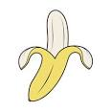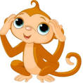

Share bananas equally between the monkey and the elephant. How many bananas does each one get? Are there any bananas left over?

Grouping could be modelled using a number line. Use prepared fully marked and fully numbered number lines to begin with and also draw own ‘groups’ (jumps) as appropriate, e.g. 8 children are put into teams of 2. How many teams are there? I.e. How many groups of 2 are there in 8?

0 1 2 3 4 5 6 7 8

8 ÷ 2 = 4 ‘eight children divided into groups of two, makes four groups’

Y2
End of Year Objective:
Calculate mathematical statements for division within the multiplication tables and write them using the division (÷) and equals (=) signs.

Children will use Numicon shapes to have a firm visual image and practical aspect to division. They will see how many times 3 there are in 12.

Children will utilise practical equipment to represent division calculations as grouping (repeated addition) and use jottings to support their calculation.

12 ÷ 3 =

Children need to understand that this calculation reads as 'How many groups of 3 are there in 12?'

They should also continue to develop their knowledge of division with remainders, e.g.

13 ÷ 4 =

13 ÷ 4 = 3 remainder 1

Use repeated addition as a method of grouping by counting up. Without remainders, and then with remainders. Use fully marked and fully numbered number lines moving onto empty number lines when children gain confidence.

30 ÷ 3 = 6

0 5 10 15 20 25 30

Remainders
20 ÷ 3 = 6 r 2
r r

0 3 6 9 12 15 18 19 20

Children need to be able to make decisions about what to do with remainders after division and round up or down accordingly. In the calculation 13 ÷ 4, the answer is 3 remainder 1, but whether the answer should be rounded up to 4 or rounded down to 3 depends on the context, as in the examples below:

I have £13. Books are £4 each. How many can I buy?
Answer: 3 (the remaining £1 is not enough to buy another book)

Apples are packed into boxes of 4. There are 13 apples. How many boxes are needed?
Answer: 4 (the remaining 1 apple still needs to be placed into a box)

Y3
End of Year Objective:
Write and calculate mathematical statements for division using the multiplication tables that they know, including for two-digit numbers divided by one-digit numbers, progressing to formal written methods.*

*Although the objective suggests that children should be using formal written methods, the National Curriculum document states “The programmes of study for mathematics are set out year-by-year for key stages 1 and 2. Schools are, however, only required to teach the relevant programme of study by the end of the key stage. Within each key stage, schools therefore have the flexibility to introduce content earlier or later than set out in the programme of study.” p4
It is more beneficial for children’s understanding to go through the expanded methods of calculation as steps of development towards a formal written method.

Initially, children will continue to use division by grouping (including those with remainders), where appropriate linked to the multiplication tables that they know (2, 3, 4, 5, 8 and 10), e.g.

43 ÷ 8 =

43 ÷ 8 = 5 remainder 3

In preparation for developing the ‘chunking’ method of division, children should first use the repeated subtraction on a number line alongside the continued use of practical equipment. There are two stages to this:

Stage 1 – repeatedly adding individual groups of the divisor
Stage 2 – adding multiples of the divisor (initially 10 groups and individual groups, then 10 groups
and other multiples in line with tables knowledge)

After each group has been subtracted, children should consider how many are left to enable them to identify the amount remaining on the number line.

Stage 1

43 ÷ 10 = 4 r 3

X1 x1 x1 x1 r r r
0 10 20 30 40 41 42 43

Stage 2

98 ÷ 6 = 16r2

6 x 10 6 x 6 r r

0 60 96 97 98

Children should be able to solve real life problems including those with money and measures. They need to be able to make decisions about what to do with remainders after division and round up or down accordingly.

Y4
End of Year Objective:
Divide numbers up to 3 digits by a one-digit number using the formal written method of short division and interpret remainders appropriately for the context.

Children will use Numicon shapes if needed to have a firm visual image and practical aspect to division. They will see how many 4 shapes there are in 15 and how many left over.

Children will continue to develop their use of grouping (repeated subtraction) to be able to subtract multiples of the divisor, moving on to the use of'chunking', an informal method. Continue to use number lines until the children are confident.

14

4 56

-40 10x
16
-16 4x Answer: 14
0

When developing their understanding of ‘chunking/grouping’, children could utilise a ‘key facts’ box, as shown below. This enables an efficient recall of tables facts and will help them in identifying the largest group they can subtract in one chunk/group. Any remainders should be shown as integers, e.g.

73 ÷ 3
24r1
73
30
43
30
13
6
7
6
1
10x

10x

2x

2x
3
-
-
-
-
1x 3
2x 6
5x 15
10x 30
Key facts box

By the end of year 4, children should be able to use the ‘chunking/grouping informal method’ to divide a three digit number by a single digit number. To make this method more efficient, the key facts in the menu box should be extended to include 4x and 20x, e.g.
196 ÷ 6
1x 6
2x 12
4x 24
5x 30
10x 60
20x 120
Key facts box
32r4
196
120
76
60
16
12
4

20x

10x

2x
6
-
-
-

Children should be able to solve real life problems including those with money and measures. They need to be able to make decisions about what to do with remainders after division and round up or down accordingly.

Y5
End of Year Objective:
Divide numbers up to 4 digits by a one-digit number using the formal written method of short division and interpret remainders appropriately for the context.

Children may continue to use the key facts box for as long as they find it useful. Using their knowledge of linked tables facts, children should be encouraged to use higher multiples of the divisor. Any remainders should be shown as integers, e.g.

523 ÷ 8
65r3
523
320
203
160
43
40
3

40x

20x

5x
8
-
-
-

By the end of year 5, children should be able to use the informal method to divide a four digit number by a single digit number. If children still need to use the key facts box, it can be extended to include 100x.

2458 ÷ 7
351r1
2458
2100
358
350
8
7
1
300x

50x

1x
7
-
-
-

Children should be able to solve real life problems including those with money and measures. They need to be able to make decisions about what to do with remainders after division and round up or down accordingly.

Y6
End of Year Objective:
Divide numbers up to 4 digits by a two-digit number using the formal written method of short division where appropriate, interpreting remainders according to the context.
Use written division methods in cases where the answer has up to two decimal places.

To develop the chunking method further, it should be extended to include dividing a four-digit number by a two-digit number, e.g.

6367 ÷ 28
227r11
6367
5600
767
560
207
140
67
56
11
28
-
-
-
-

200x

20x

5x

2x

Children should be able to solve real life problems including those with money and measures. They need to be able to make decisions about what to do with remainders after division and round up or down accordingly.

In addition, children should also be able to use the chunking method and solve calculations interpreting the remainder as a decimal up to two decimal places, e.g. 362 ÷ 17

362 ÷ 17
17
-
-
-
-
21.29
362
340
22
17
5.0
3.4
1.60
1.53
0.07
20x

1x

0.2x

0.09x
To enable children to continue the calculation, they need to understand that 5 is the same as 5.0

When recalling and deriving multiplication and division facts, children should also identify decimal equivalents of times tables,
e.g. if 2 x 17 = 34, I know that 0.2 x 17 = 3.4
if 9 x 17 = 153, 0.9 x 17 = 15.3 so 0.09 x 17 = 1.53

For simple fraction and decimal equivalents, this could also be demonstrated using a simple calculation such as 13 ÷ 4 to show the remainder initially as a fraction.

Using practical equipment, children can see that for 13 ÷ 4, the answer is 3 remainder 1, or put another way, there are three whole groups and a remainder of 1. This remainder is one part towards a full group of 4, so is . To show the remainder as a fraction, it becomes the numerator where the denominator is the divisor (the number that you are dividing by in the calculation).

3574 ÷ 8

3574
3200
374
320
54
48
6
remainder

divisor
6
8
400x

40x

6x
8
-

-

So 3574 ÷ 8 is 446
(when the remainder is shown as a fraction)

-

To show the remainder as a decimal relies upon children’s knowledge of decimal fraction equivalents. For decimals with no more than 2 decimal places, they should be able to identify:

Half: = 0.5
Quarters: = 0.25, = 0.75
Fifths: = 0.2, = 0.4, = 0.6, = 0.8
Tenths: = 0.1, = 0.2, = 0.3, = 0.4, = 0.5, = 0.6, = 0.7, = 0.8, = 0.9

and reduce other equivalent fractions to their lowest terms.
In the example above, 3574 ÷ 8, children should be able to identify that the remainder as a fraction of can be written as in its lowest terms. As is equivalent to 0.75, the answer can therefore be written as 446.75

Short division

It is also important to introduce short division method at this stage for whole numbers and decimals.

e.g.
456 ÷ 8 = 57

5 7
8 4556

Decimals

27.6 ÷ 6 = 4.6

4.6
6 27.36

