Answer each questions (you may need to use the internet to help you) and then take the first letter from each answer to work out the hidden question on page two.

1. | What compass direction does the sun set in?
2. | Who sat on the wall and had a great fall?
3. | Which word is ‘huevo’ in Spanish and ‘oeuf’ in French?
4. | What is the capital city of Iceland?
5. | What Christian holiday celebrates Jesus coming back to life?
6. | What is Tony Stark’s superhero name?
7. | What medal do you get for coming 2nd in the Olympics?
8. | What form of transport runs on rails?
9. | Who is the main character in JK Rowling’s novel ‘The Philosopher's Stone’?
10. | What part of the body contains the iris?
11. | What is a female sheep called?
12. | What USA state is the city of Chicago in?
13. | Which Roald Dahl novel has an animal stealing from 3 famers?
14. | What film has the characters Dory and Marlin?
15. | Which country would you find the ancient pyramids?
16. | Where were the 2012 Olympic Games held?
17. | What is the fairy in Peter Pan called?
18. | What colour do you get when you mix red and yellow?
19. | What was Disney’s first name?
20. | If numbers end in 0, 2, 4, 6 or 8 they are called what?
21. | Which city in Italy has the coliseum?

Hidden Question:

?

Answer to the hidden question:

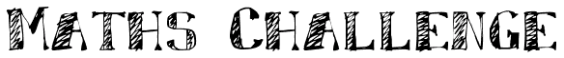
9 x 8 = 74 |  | 8 x 6 = 48
3 x 7 = 21 |  | 3 x 8 = 24
12 x 3 = 36 |  | 5 x 12 = 50
8 x 0 = 8 |  | 7 x 0 = 7
6 x 4 = 24 |  | 12 x 9 = 108
9 x 3 = 27 |  | 3 x 3 = 6
10 x 7 = 70 |  | 4 x 2 = 8
6 x 1 = 1 |  | 9 x 0 = 0
7 x 5 = 40 |  | 7 x 7 = 49
9 x 4 = 36 |  | 4 x 8 = 32

Put a cross in the box next to the calculations that are wrong:

Look at these words:

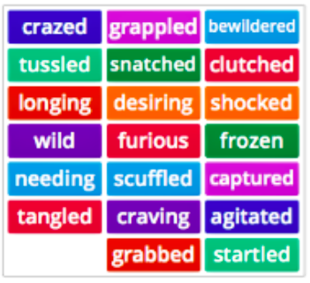

Find the words above that mean the same as the ones in the table:

Wrestled | Frenzied | Seized | Stunned | Wanting

