1. What is the tallest building in the world? → |  |  |  |  |  |  |  |  |  |  |  |  | You may need to use the internet to help you answer some of the questions.
2. Name two characters that sing ‘Hakuna Matata’ →
3. Name the three Jonas Brothers →
4. Name the four points on a compass →
5. Name five breeds of dogs →
6. Name six cities in the UK →
7. Name seven football teams →
8.
9.

8. Name eight Disney characters 9. Name nine cities that have hosted the summer Olympic Games
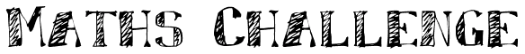  What are the missing numbers in these sequences? | Match the words in the coloured tiles with the synonyms in the table below:
  99 | 90 | 81
  50 |  |  | 35 |  |  | 20 | 15
  3 |  | 9 |  | 15
  36 | 48 |  |  | 84
  21 |  | 35 |  | 49
  12 |  | 20 |  | 28
  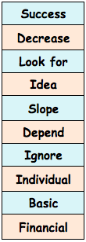 |  | Fundamental
   |  | Seek
   |  | Incline
   |  | Concept
   |  | Rely
   |  | Distinct
   |  | Economic
   |  | Achievement
   |  | Decline
   |  | Exclude

