Year 6  Toucans  Week beg. 15th June | Before 9:00am | 9:00 – 10:00 | 10:00-11:00 | 11:00-12:00 | Lunchtime – 12:00 -12.30 | 12:30 – 1.00 | 1:00 – 2:00 | 2:00 – 3:15 | 3.15 – 4:00
Monday | Eat breakfast, make your bed, get washed and dressed, any laundry in the basket. | Family walk with the dog (if you have got one!)  Five-day/indoor exercises/indoor yoga or other exercise if wet.  https://www.youtube.com/user/CosmicKidsYoga  https://www.gonoodle.com/  https://www.nhs.uk/10-minute-shake-up/shake-ups  www.5-a-day.tv USERNAME: 5-a-dayAtHome PASSWORD: AtHome123 | Work from the packs that have been sent home/CGP books/First4Maths activities/fluency grids/any specified work from the daily blog  TT Rock Stars - https://play.ttrockstars.com/auth/school  White Rose Maths https://whiterosemaths.com/homelearning  I See Reasoning lessons http://www.iseemaths.com/home-lessons/ | Creative Time – Lego, drawing, crafting, music, cooking, baking, coding, painting.  coding - https://www.scratchjr.org/ https://code.org/  Ted Ed https://ed.ted.com All sorts of engaging educational videos.  Blockly https://blockly.games Learn computer programming skills - fun and free. | Lunchtime – 12:00 -12.30 | Tidy Time – Wipe down kitchen table and chairs, wash and dry kitchen dishes, tidy bedroom and lounge | Quiet Time – Reading, Puzzles, Nap (No Electronics) | Languages/Art  German Website: www.atantot.com User name: lostockgralam Pass: 1443 | Afternoon Fresh Air – Bike, Walk the dog, play outside. Have a go at some of the active challenges https://www.youthsporttrust.org/pe-home-learning  https://www.youthsporttrust.org/60-second-physical-activity-challenges  https://www.youthsporttrust.org/active-learning
Tuesday |  |  |  |  |  |  |  | Science/PSHCE  https://mysteryscience.com/
Wednesday |  |  |  |  |  |  |  | History/Geography
Thursday |  |  |  |  |  |  |  | Science  https://mysteryscience.com/
Friday |  |  |  |  |  |  |  | RE/Geography
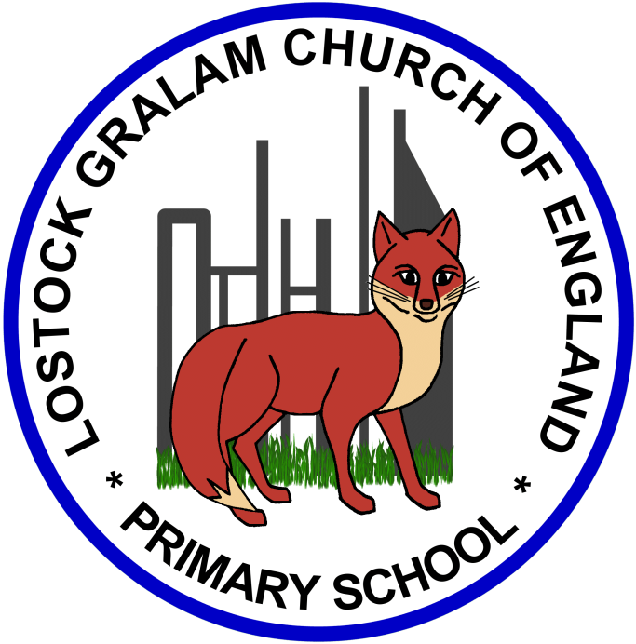
Home Learning – this timetable is intended as a guide to support learning at home during a prolonged period of school closure. We appreciate that you will have differing demands on your time but hope that this helps in continuing ‘a love learning’ at home. We will also be updating the class blog daily with any specific activities that you can do each day and further resources that you may need.
Mrs Downing & Mrs Whittingham
If you have issues with usernames and passwords, please contact admin@lostockgralam.cheshire.sch.uk
Monday | Art/Geography – Spirit of the Rainforest  Continuing with our South American project work, today you will explore rainforest plants.  Take your time to work through the attached slides, answering the questions and learning the facts as you go.  Then have a go at painting a banana plant. | 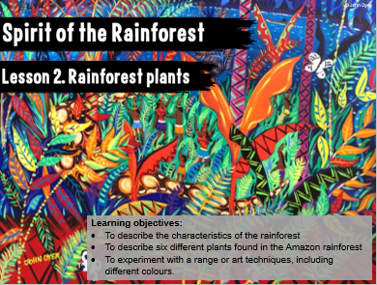
Tuesday | PSHCE - Transition  Take a look at the attached picture book about worries. You might remember when we were in Year 5 we went to the Grange and did some artwork based on the work of Jon Burgerman.  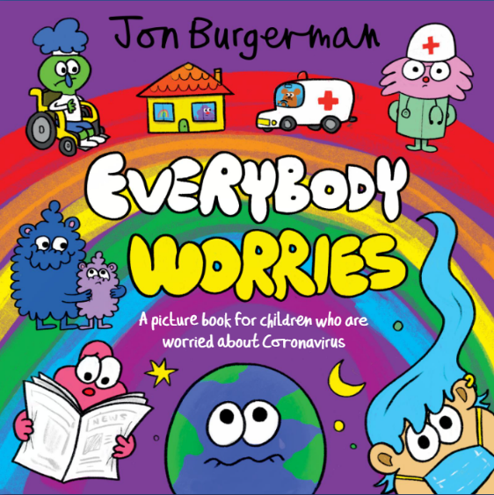  Also over the next couple of weeks I’d like you to work through the clips on the BBC website that will help you with transition  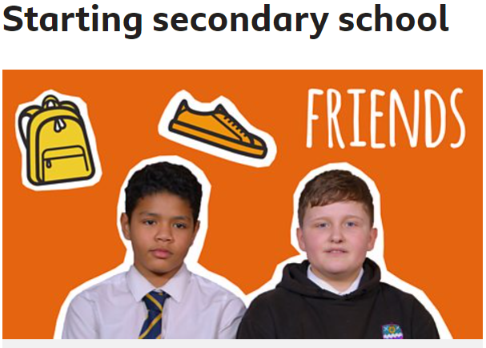  https://www.bbc.co.uk/bitesize/tags/zh4wy9q/starting-secondary-school/1
Wednesday | History – Maya Civilisation Project  What have you found out about the Mayans?  We will continue our study of the ancient Mayans today. I would like you to think about how you can record what you have learnt so far and will learn over the next few weeks about the Mayans. Think about how we would represent this work if we were in school. You could create a poster, a PowerPoint, use Word to type up questions/answers or a fact file, create some art work etc. Be as creative as you can. Also have a look at the cross curricular art work. Could you create a piece of art work? Do you like Maths – the Mayans were great mathematicians!  Take a look at these BBC video clips to learn more about the Mayans  https://www.bbc.co.uk/bitesize/topics/zq6svcw  https://www.bbc.co.uk/teach/class-clips-video/history-ks2-introducing-the-maya-civilisation/znk3cqt  Useful websites/links  https://www.youtube.com/watch?v=AE2JxR7KQzA  www.mayankids.com  http://mayas.mrdonn.org/games.html  A History of Chocolate  https://www.bbc.co.uk/bitesize/articles/zngsqp3 | 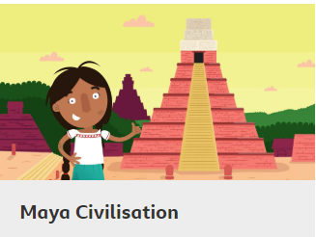  Cross curricular ideas for your project work  - Geography link to the Americas – Which countries today formed the ancient Mayan lands? (Much of Mexico and Guatemala, all of Belize and parts of Honduras and El Salvador.)  - Study Mayan writing – they used symbols called hieroglyphs. Compare with other ancient civilisations’ writing.  - Maths – The Mayans also invented a number system – they used just 3 symbols a “shell” to mean zero, a “dot” for one and and a horizontal line to represent five. Which numbers can you represent?  - Maths – investigate the Mayan Calendar  - Science link – Stargazing/ Astronomy.  - Design technology – Savoury dishes – tortilla, guacamole, salsa, chilli con carne etc.  - Mask making – Design Technology/ Art
Thursday | Science – Everything Changes – What evidence is there that living things have changed over time?  - Look at the attached fossil cards and sort into order.  - Look at the Fossilised fish photo (PowerPoint 1st slide) and draw a picture of what you think this animal looked like when it was alive. Remember that fossils are a way of ‘looking into the past’ at living things that existed millions of years ago, most of which no longer exist.  How do we know this animal did not live on land? How much evidence do we have that this animal lived in a watery environment?  - Look at slides 2 – 4 of other Fossilised plants and animals  What do these fossils look like? What kinds of environments do you think they lived in?  What evidence do you get from looking at the fossil?  What other evidence might you need to be more certain?  - Look at the fossil examples and choose one to research or find out more about fossils yourself and create a presentation in any form that you wish.  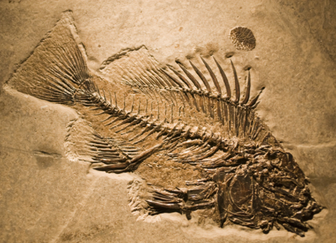  When was this animal living on the Earth? What other types of living thing were also on the Earth at the same time? What type of environment did it live in? Why did you give the answers you gave? How many years do you think ammonites lived on Earth? Do you think these animals stayed the same all the time or do you think they changed in some way? Are there any animals living today that are related to ammonites?  Useful websites/video clips  https://www.bbc.co.uk/bitesize/topics/z9bbkqt/articles/z2ym2p3 - how are fossils made  https://www.bbc.co.uk/bitesize/topics/z9bbkqt/articles/z22g7p3 - what can we learn from fossils  Explore habitats with this game  https://www.bbc.co.uk/bitesize/topics/z6bqkmn/articles/zj7s6v4
Friday | PSHCE – No Outsiders – Here We Are  Our world can be a bewildering place, especially if you’ve only just got here. Your head will be filled with questions, so let’s explore what makes our planet and how we live on it.  No Outsiders links: exploring difference, living together, asking questions  Use this link to hear the story -  https://www.youtube.com/watch?v=kkcjKbbF9JA&feature=youtu.be  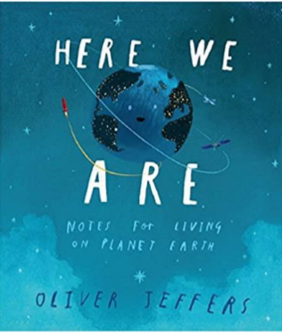  Have a look at some of the attached activities and choose some to do (There are eight worksheets here, mainly aimed at Key stage 2 and Key stage 3 pupils, although younger children may enjoy worksheet 1).

‘A Love for Learning’

