FOSSIL FORMATION CARDS

Look at the cards. Sort them into order.

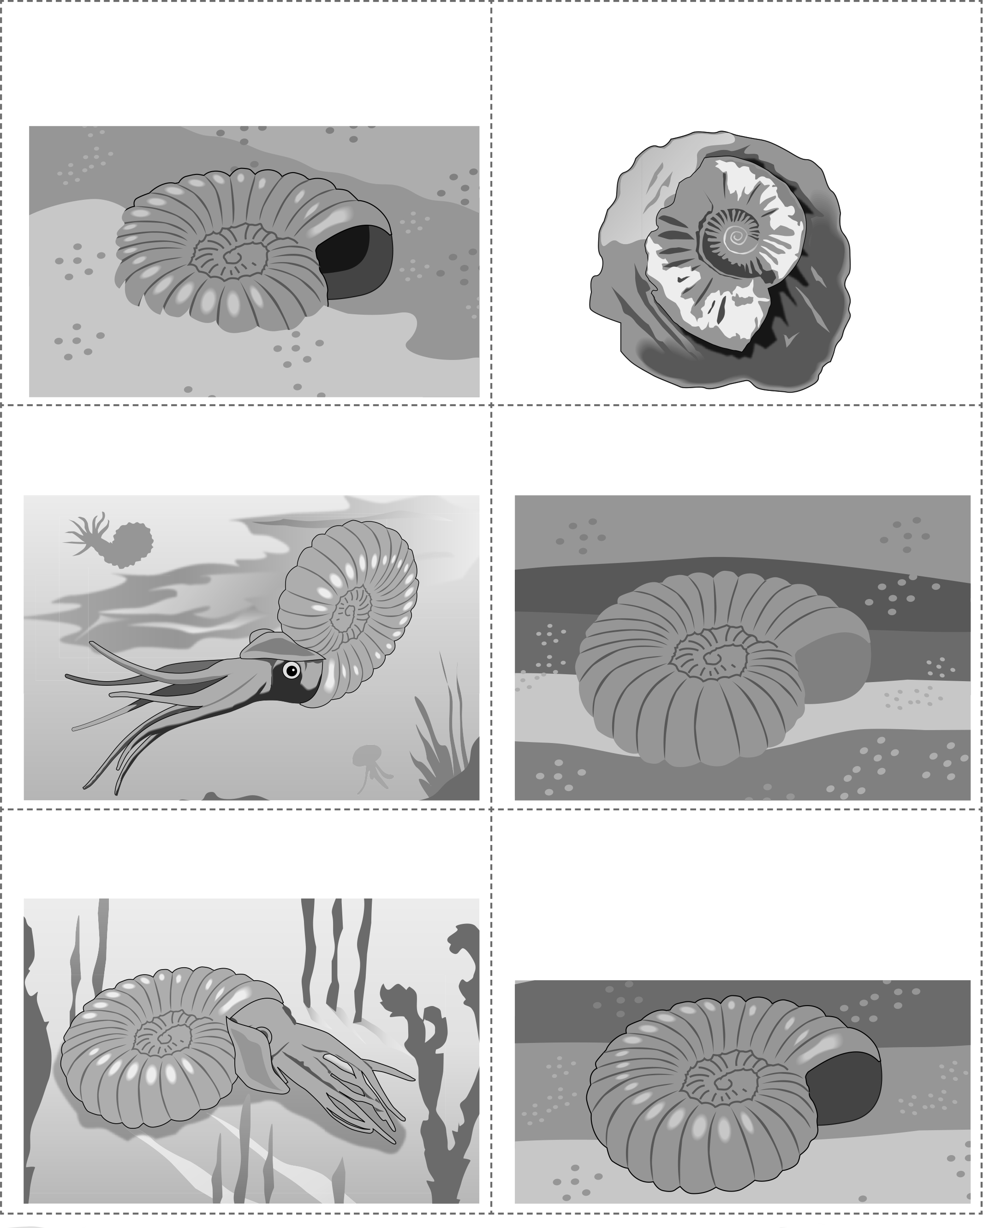

Millions of years later, the rock is broken apart and a fossil of the ammonite is found.

The fleshy parts of the ammonite rot away and the shell becomes covered in sediment.

The fossil of the ammonite shell is inside rock.

The ammonite is alive and living in the sea.

The ammonite dies and falls to the bottom of the sea.

The layers of sediment covering the shell are squashed together, slowly turning into sedimentary rock.