Answer each questions (you may need to use the internet to help you) and then take the first letter from each answer to work out the hidden question on page two.

1. | What British country has a red dragon on its flag?
2. | Who is the games keeper at Hogwarts School? (Second name only)
3. | What is the Little Mermaid’s name?
4. | What product do PG Tips and Tetley make?
5. | What food does Dominos make?
6. | What animal is Aslan in Narnia?
7. | What do you call someone who travels into space?
8. | What famous French church does the Hunchback live in?
9. | How many legs does an octopus have? (Word)
10. | BGT stands for Britain’s Got _______ ?
11. | Jurassic Park contains what extinct animal?
12. | Numbers that end in 1, 3, 5, 7 or 9 are called what?
13. | What is the capital city of New Zealand?
14. | Who sang Jailhouse Rock?
15. | Which American city is famous for its casinos?
16. | Which religion has the prophet Muhammad?
17. | What is a doctor for animals called?
18. | What competition has countries across Europe singing different songs?
19. | What is a shape with eight sides called?
20. | What ice cream has chocolate, strawberry and vanilla in one tub?

Hidden Question:

?

Answer to Hidden Question:

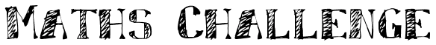

Complete this table using your X tables facts:

X
 | 77 |  |  |  |  | 66
 |  | 12 |  |  | 9
 |  |  | 24 |  |  | 48
 |  | 36 |  | 15
 | 28 |  |  |  | 36
 |  |  |  | 50 |  | 60
 | 14 |  | 6
 |  | 84 |  |  | 63

Match the words in the coloured tiles with the synonyms in the table below:

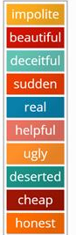 |  |  | Rude
 |  |  | Inexpensive
 |  |  | Empty
 |  |  | Pretty
 |  |  | Truthful
 |  |  | Hideous
 |  |  | Lying
 |  |  | Supportive
 |  |  | Authentic
 |  |  | Abrupt

