Ear

Ear drum | Auditory nerve | Semi circular canals.  (three bones)
Eusatchian tube | Ear flap (pinna) | Ear canal | cochlea
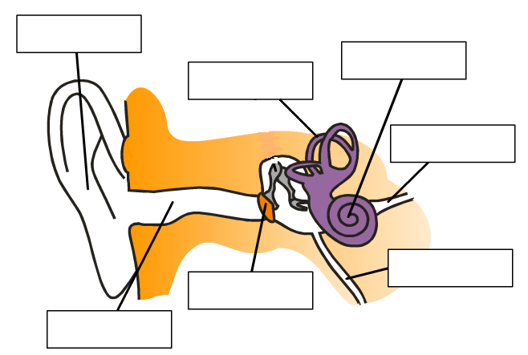

Ear flap collects the sound


Ear drum vibrates and passes the vibrations to the three bones.
Sound vibrates and passes through the ear-canal and hit the ear drum
Three bones vibrate and pass on the vibrations to the cochlea.
Tiny hairs on the cochlea vibrate and pass messages to the brain.
Object vibrates causing the air particles vibrate.





