|  |  |
| --- | --- |
| **Friday 26th February 2021** |  |
| **Can I describe what lives in a desert habitat?** |

***✍ How would you describe a desert?***

Deserts are _______________________________________________________

_________________________________________________________________

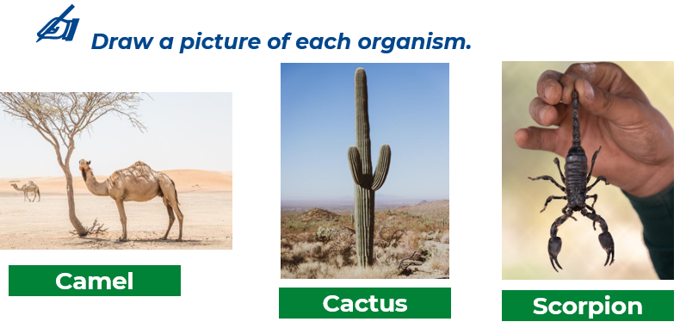

|  |  |
| --- | --- |
| Picture |  |
|  | _______________________________________________________ _______________________________________________________ _______________________________________________________ _______________________________________________________ _______________________________________________________ _______________________________________________________ |
|  | _______________________________________________________ _______________________________________________________ _______________________________________________________ _______________________________________________________ _______________________________________________________ _______________________________________________________ |
|  | _______________________________________________________ _______________________________________________________ _______________________________________________________ _______________________________________________________ _______________________________________________________ _______________________________________________________ |